SPECIFICATION

LICENSE PLATE SHEETING,

THERMAL TRANSFER RIBBONS

AND PROTECTIVE CLEAR FILM

FOR DIGITAL LICENSE PLATE PRODUCTION

3M™ Digital License Plate Reflective License Plate Sheeting Series 9250T

June 2010

(SP DLP)

DIGITALLY PRINTED LICENSE PLATE SPECIFICATIONS__________________________

June 2010

SECTION I - GENERAL

This specification shall cover the materials, performance characteristics, quality, and testing of retroreflective sheeting and support services necessary to produce digitally printed license plates.

A. DESCRIPTION:

1. The retroreflective license plate shall consist of retroreflective (hereinafter referred to as “reflective” only) sheeting that is digitally printed with thermal transfer ribbons and then laminated to a specified aluminum substrate according to the sheeting manufacturer’s recommendations.

2. The reflective sheeting shall consist of lens elements enclosed within a transparent resin and shall have a pre-coated pressure sensitive adhesive backing protected by a removable liner.

3. The reflective sheeting, when applied to the license plate substrate and blanked to finished size, shall contain:

  - Identifying marks for purposes of on-vehicle traceability, warranty enforcement and anti-counterfeiting in accordance with these specifications. The warranty marks shall be buried below the sheeting surface for durability and shall incorporate the manufacturer’s production run number that designates the source of manufacture, year of manufacture, and specific lot from which the material was supplied. The warranty marks shall not interfere or detract from the graphic design or reduce sheeting brightness and shall be durable for the service life of the license plate.

  - A three-dimensional security mark that runs from the top to the bottom of the plate or from the left to the right side of the plate. The security image shall consist of a double sine wave pattern where one wave appears to float above and one wave appears to float below the directional warranty image of the reflective sheeting. The virtual security thread shall be durable for the service life of the license plate.

4. Pre-printed reflective sheeting shall conform to the design, colors and sheeting type as approved by the state and reflective sheeting manufacturer.

B. PREQUALIFICATION

Before any bid is considered, the vendor shall meet the following criteria:

1. To assure high quality license plate performance, durability and service, the successful sheeting manufacturer shall provide the state with proof of successful L/P manufacturing in other states. The successful bidder shall provide the following documentation with the bid:
a. Show evidence of successful manufacture of reflective sheeting, thermal transfer ribbons and protective clear overlaminate, as parts of a totally integrated license plate system.

- Provide a list and qualifications of experienced, full-time graphic design, customer service, technical service and sales service personnel.

c. Submit a plan for providing expert on-site technical service within 48 hours and immediate toll-free call-in technical service.

d. Submit a plan for next day delivery of stocked equipment parts; provide the using agency with a detailed list of stocked parts.

- Provide independent test lab data demonstrating that the bidder’s products conform to all performance requirements of this specification as specified in Section II. Additional testing will be conducted by the State’s designated test lab.

- Properly warrant the plates produced from the manufacturer’s sheeting by posting a $1,000,000 product bond during the duration of this issue. The sheeting manufacturer shall also provide buried directional warranty mark in the sheeting in accordance with Section IV.B, which facilitates on-vehicle traceability and warranty enforcement.

- Supply sample rolls of sheeting printed with graphic designs to be designated by the State to demonstrate the supplier’s production capability to providing general issue designs.

- Supply evidence of successfully supplying reflective sheeting and digital license plate production systems to another state with comparable production volume.

2 The sheeting manufacturer will provide all necessary samples for the agency or their designated testing facility to certify the material compliance with these specifications. At the request of the agency, the sheeting supplier may also be required to compensate the agency or their testing agents for the cost of any material testing.

3. A corporate officer shall certify that all license plate sheeting thermal transfer ribbons and protective clear laminate purchased by the state are covered by the sheeting manufacturer ISO 9001 Registration.

- The supplier shall submit technical data exhibiting characteristics of all materials proposed. Information submitted shall include detailed processing conditions for each phase of license plate manufacture.

- Vendors failing to conform to any of these prequalification requirements shall be disqualified.

C. PERIODIC EVALUATION:

The state reserves the right to periodically evaluate the performance of materials. Samples for periodic evaluation of performance will be selected at random from materials submitted on state purchase orders. Failure of materials to comply with the requirements of this specification shall be cause for removal.

D. TECHNOLOGICAL IMPROVEMENTS

The sheeting manufacturer may, with agreement of the state, incorporate technological improvements that better optimize the license plate production process and/or license plate performance.

SECTION II – PERFORMANCE STANDARDS
REFLECTIVE SHEETING FOR DIGITAL LICENSE PLATE PRODUCTION

1. Substrate

The sheeting shall be laminated to aluminum substrate recommended by the sheeting manufacturer.

2. Diffuse Daytime Color

Through instrumental color testing, the diffuse daytime color of the reflective sheeting shall conform to color requirements as determined spectrophotometrically in accordance with ASTM E-1164 and E-1349, utilizing either 45/0 or 0/45 degree illumination/viewing conditions as described in E-1164 and E-1349 for retroreflective materials. Chromaticity and the Luminance Factor based on CIE tristimulus values for the 2° observer and illuminant D65 shall be calculated in accordance with ASTM E-308.

The color specification limits for white license plate sheeting are listed on the following chart.

COLOR SPECIFICATION
Chromaticity Coordinates

Pairs | White  Corner Points |  | Luminance Factor
Pairs | x | y | Y%
1 | .303 | .287 | 42 min.
2 | .368 | .353
3 | .340 | .380
4 | .274 | .316

3. Adhesive and Protective Liner:

a. The precoated adhesive shall form a durable bond to flat conversion coated license plate surfaces as recommended by the reflective sheeting manufacturer.

b. The protective liner attached to the adhesive shall be removable by peeling without soaking in water or other solvents and shall be easily removed after accelerated conditioning for four hours at 150°F (66°C) under weight of 2.5 lbs. per square inch (1.14KG per 6.45 sq. cm). The liner shall be non-printed to permit reuse.

4. Thermal Transfer Printing

- The reflective sheeting shall be printable with thermal transfer ribbons supplied by the sheeting manufacturer.

- The sheeting manufacturer shall provide a complete line of thermal transfer ribbons, in process and spot colors, that allow the license plate shop to print the graphic designs and variable information required by the state.

- Protective Clear Overlaminate

The sheeting manufacturer shall provide a protective clear film that will be laminated to the sheeting in-line with the thermal transfer printing process. Printed sheeting with the protective clear film shall pass all performance tests as delineated in Section II.B.

- Inventory Control

To assist the license plate shop with inventory control problems, the sheeting
manufacturer shall mark the sheeting with an integral, directional image
that incorporates the lot number so that the tag shop can employ first in - first
out principles.
B. FINISHED LICENSE PLATES

Test panels shall be prepared in accordance with Section III, Para. A.

1. Retroreflective Characteristics

a. The coefficient of retroreflection for the sheeting shall be measured on flat, clean, finished license plate test panels prepared per Section III and shall have the following minimum values at 0.2° observation angle, expressed as candelas per lux per square meter of material. Measurements shall be conducted in accordance with ASTM E-810, “Standard Test Method for Coefficient of Retroreflection of Retroreflective Sheeting”. Measurements on reflective sheeting with a preprinted graphic design shall be taken in an unprinted sheeting area.

Color | Entrance Angle
 | -4° | 40°
White | 50 | 16
2. Resistance to Accelerated Weathering.

- The sheeting shall be weather resistant and show no appreciable discoloration, crazing, cracking, blistering, lifting or dimensional change and the surface shall continue to be essentially smooth to provide direct application of validation stickers, determined after the following accelerated weathering tests:

- Laboratory testing – 2,000 hours in Xenon arc weatherometer using ASTM G 155 -Type BH, Cycle 1. Samples shall maintain 70% of retroreflective table values shown in II, B. 1.

- Outdoor accelerated testing – Samples shall be placed in a 24 month unprotected outdoor exposure, facing the equator and positioned vertically. Retroreflective measurements, taken after cleaning, shall result in 70% or more retention of the table values shown in II, B. 1.
3. Rainfall Performance

a. The Coefficient of Retroreflection of the same finished license plate test panels, measured on the same flat area of the test panels, totally wet by rain, shall not be less than 90 percent of the values specified above. The photometric performance during rainfall shall be determined as follows:
  - Test set-up for rainfall performance:
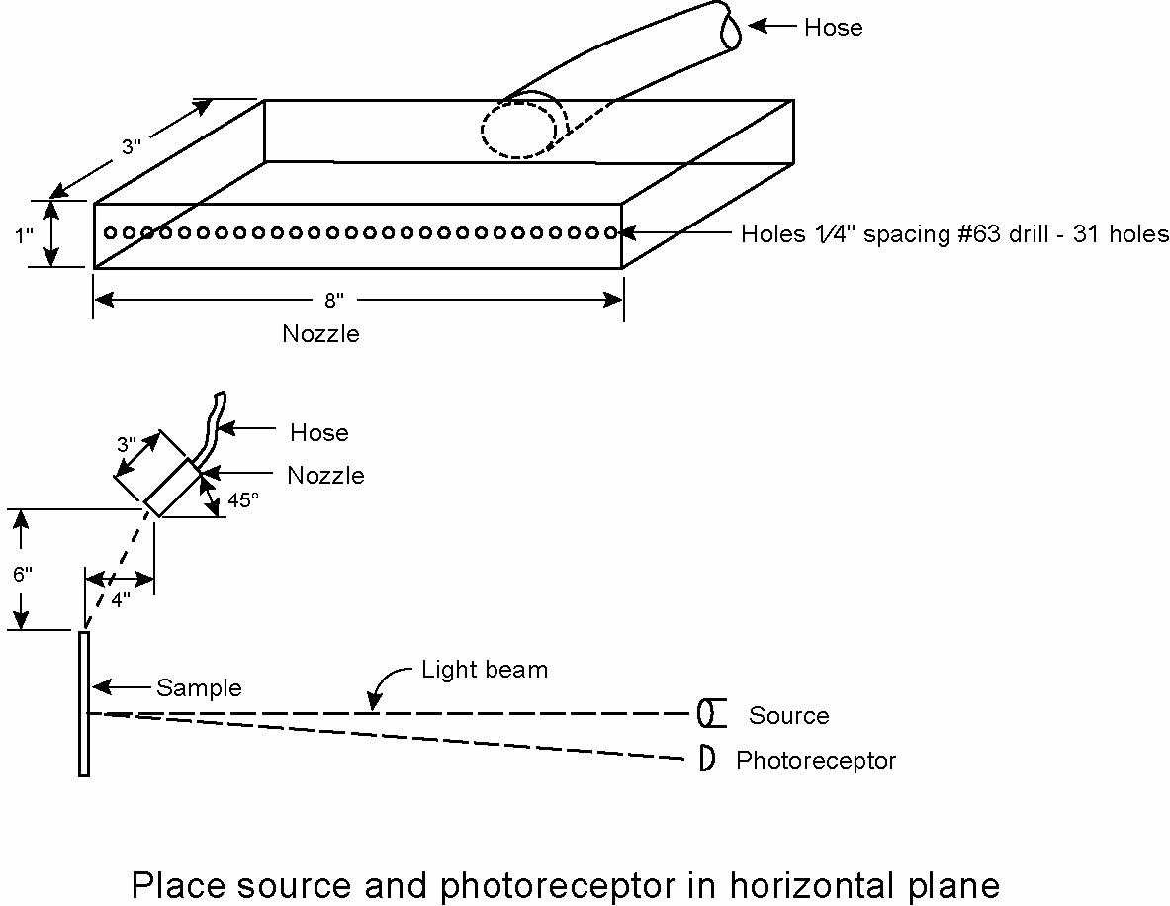

  - Place the test panel in an upright position 6 inches (15.2 cm) below and 4 inches (10.1 cm) in front of the nozzle as shown below:
  - Apply sufficient water pressure so that the upper surface of the spray envelope strikes the top of the panel.
  - With water falling on the panel, measure the coefficient of retroreflection. Wet performance measurements shall be conducted at 0.2° observation and -4° entrance angles in accordance with ASTM E-810.

4. Daytime/Nighttime Color

To assist in positive daytime/nighttime identification of license plates, the color of the reflective background of the sheetings, including any pre-printed design or digitally printed design, shall be similar in daylight and by illumination at night.

5. Flexibility - Embossing

- The sheeting shall, when correctly applied to treated aluminum, conform to the minimum/maximum tolerances for an embossed rim or flange as used by the manufacturing facility that supplies finished plates to the state and as recommended by the sheeting manufacturer.

- Finished license plates shall show no appreciable wrinkling, cracking, or squirming at or around the embossed rim or flange.

6. Cleanability.

- Finished license plates, manufactured in accordance with the recommendations of the reflective sheeting manufacturer, shall be easily cleansed of normal dirt accumulation by washing with water and mild detergent. A test panel shall be sprayed with water-suspended soils collected from the underside of vehicle fenders, mixed with water in the proportion of five pounds (2.27 kg) of soil to one gallon (3.78 liters) of water, and poured through a paint strainer.

- The mixture shall then be sprayed onto the panel while particles are in suspension. After the panel is thoroughly dry, it shall be cleaned by washing with a mixture of water and mild detergent, rinsed with clean water and wiped dry for examination. The panel shall show no appreciable difference when compared to a new clean panel.

7. Solvent Resistance

- License plate panels prepared per III.A shall be sufficiently solvent resistant to withstand exposure to mineral spirits and turpentine in accordance with the test method described in this section without wrinkling, puckering or edge lifting.

- Test panels shall be 1 inch x 6 inch strips cut from license plate blanks. Strips of the license plate shall be exposed as follows: mineral spirits and turpentine - submerged in a container with 4 inches of solvent for 10 minutes.

- Samples shall be allowed to dry and be examined for any wrinkling, puckering, blistering, or edge lifting. Failure of samples shall be cause for rejections.

SECTION III - TEST PANELS AND QUALITY CONFORMANCE

A. TEST PANELS

Finished license plate test panels 6” x 12” (15.2cm x 30.5cm) must be provided for testing and evaluation within ten (10) calendar days if required by the state, and shall be produced of the same materials, on the same equipment and by the same general processes of substrate preparation as the production plates, in accordance with the sheeting manufacturer’s recommendations. Test panels shall be provided with and without thermal transfer printed graphics and variable information as required by the state.

B. QUALITY CONFORMANCE

Failure of the reflective sheeting to meet any requirement specified herein shall be cause for refusal to accept materials until evidence has been provided by the manufacturer that corrective action has been taken to eliminate deficiencies.

SECTION IV - PERFORMANCE LIFE & WARRANTIES

A. PERFORMANCE LIFE

1. Reflective sheeting applied and processed into finished license plates according to the sheeting manufacturer’s instruction shall be considered to perform effectively for the service life specified (excluding those plates showing mechanical damage) if:

a. The plates show no fading, cracking, blistering or peeling which will significantly impair the intended visibility or legibility of the plate, and if

b. The clean rear plate retains at least 9 candlepower per foot-candle per plate (.84 candelas per lux per plate) for the length of the intended issue being bid. (up to a period of 5 years). Measurements shall be taken in clean, white, unprinted areas of rear plates.

2. Measurements shall be conducted at 0.2° observation angle and -4° entrance angle. Coefficient of Luminous Intensity shall be measured using the test method outlined in ASTM E-810 except that the coefficient of luminous intensity shall be determined in accordance with ASTM E-808-01 Para. 3.2.2 and ASTM E-809-02 Para. 12.3. Note: Reflective license plates with a digitally printed graphic design may not meet this requirement as large graphic printed areas may affect the reflectivity levels of the finished license plates.

B. WARRANTY PROVISIONS

1. The sheeting shall be imaged with a directional, integral warranty mark, so as to be traceable to the specific manufacturer’s production run numbers from which the material originated. If at any time during the specified performance life of the reflective material provided, a one half of one percent sample of clean, rear plates produced from a given production run (identified by the integral warranty mark) reveals that 10 percent or more of that sample are found to be defective in visual or brightness performance requirements as defined herein, the vendor shall be responsible for replacement of all plates manufactured from that specific lot of material.

2. The sheeting manufacturer shall be responsible for all replacement costs associated with a specific lot; a maximum liability assessment of $5.00 per plate will be invoked for failed plates associated with a specific lot. Reimbursement of the State shall be in dollars and/or materials equal to the assessed damage, at the State’s discretion.

3. To assure effective identification, the warranty marks shall be approximately 1.125 inches in diameter on standard 6” x 12” plates and shall be of a design mutually agreed upon by the State and the sheeting manufacturer. The manufacturer may vary the number, design and placement of the marks for motorcycle or smaller license plate sizes.

4. The warranty marks shall be verifiable on a license plate once properly affixed to the vehicle’s designated mounting area, from an approximate head-on distance of six (6) feet; warranty marks shall not be observable at 2 feet or 20 feet or when the viewer steps to one side from the head-on viewing position so as not to compete or conflict with vital plate information.

- The warranty marks shall be verifiable under both ambient light and retroreflected light at night, shall not interfere or conflict with the plate design or aesthetics, and shall not alter sheeting colors or reduce sheeting brightness below specified levels.

- Three-dimensional Security Mark

  - The retroreflective sheeting shall also have a three-dimensional security mark that runs vertically or horizontally through standard vehicle registration plates for purposes of security and anti-counterfeiting in accordance with these specifications. The three-dimensional security mark shall be buried beneath the surface of the sheeting and shall consist of two sinusoidal waves where one wave appears to float above and one wave appears to float below the warranty marks of the retroreflective sheeting. The three-dimensional security mark shall be durable for the service life of the license plate.

  - The three-dimensional security mark shall be verifiable under both daylight and retroreflected light, shall not interfere or conflict with the plate legibility, and shall not reduce sheeting brightness below minimum specified brightness levels when measured in accordance with ASTM E 808 and ASTM E 809.

  - The three-dimensional security mark shall be visible in the unprinted areas of the plate from within a standard police vehicle under high beam headlight illumination, as well as outside of the vehicle, on a license plate properly affixed to the vehicle’s designated mounting area, from an approximate distance of 0 to 40 feet (0 to 12 meters) at a head-on viewing angle. The two sinusoidal wave images shall be visibly distinct from an approximate distance of 0 to 20 feet (0 to 6 meters). The three-dimensional security mark shall not be visible when viewed at an angle greater than 45 degrees from the head-on viewing position.

SECTION V - PACKAGING AND SHIPPING

To ensure easy access and proper inventory control, the reflective sheeting shall be shipped in bulk packages. To prevent roll damage, each pallet of bulk packages shall be designed to prevent double stacking by the shipper. Production run sequence numbers shall be affixed to the outside of each shipping package that corresponds to the materials contained therein. Each roll shall be additionally designated by a core identifier stamped or affixed with a permanent label to the inside of each roll core. A shipping or packaging list shall be affixed to one box on a pallet identifying all production runs contained within the shipment.

SECTION VI - DELIVERY SCHEDULE

All deliveries shall be provided F.O.B. to the state’s designated point of delivery. The first expected delivery of reflective sheeting shall be not later than 45 days following official notification of contract award, initial order and receipt of state approved artwork. All subsequent orders shall be F.O.B. destination with expected delivery within 30 days after receipt.

SECTION VII - ACCOUNTABILITY

The manufacturer shall be accountable for all sheeting from the place of manufacture to the point of delivery. All over-run materials remaining in the manufacturer’s possession after discontinuation of any design or the contract’s cancellation, shall be destroyed and used for no other purpose.

SECTION VIII - PROCESSING

The reflective sheeting processing shall be in accordance with the recommendations of the manufacturer. All processing procedures for reflective material, thermal transfer ribbons and clear protective laminate must be compatible, or made compatible at the vendor’s expense, with equipment and procedures currently employed by the state.

