

3M™ Paint Protection Film Series 150 Gloss

Technical Data Sheet Series 150 Gloss vision A, March 2024

Re

# Product Description

* Designed to protect automotive paint and other vulnerable surfaces of the vehicle from stone chips, scratches, bug damage, road tar, stains, automotive fluid stains, and punishing outdoor weathering including harsh ultraviolet (UV) radiation
* Guard vehicle paint and other vulnerable surfaces of the vehicle against rocks, keys, salt, bugs and the elements
* High stain resistance for a low maintenance finish to repel against water and dirt
* Exceptional clarity with lower orange peel to help maintain the brilliance of the vehicle paint
* Highly flexible construction easily stretches over difficult contours and conforms into deep recesses
* Optimized adhesive for repositioning, minimizing lift lines and adhesive marks
* Self-healing technology allows minor scratches to disappear with heat applied to the film surface
* Virtually invisible protection
* 10-year consumer warranty*

Approved to be used with 3M™ Pattern Marketplace, the latest innovative digital pattern software with nearly 4,500 quality-tested paint protection film and auto window film patterns going back more than ten model years. Designed with 3M’s installers and products in mind, this cloud-based system offers flexible purchase options, key pattern editing features, and ongoing development to continue delivering intuitive tools to help improve the installation experience.

* Ask a 3M authorized installer or see the warranty card for complete details.

## Recommended Applications

* 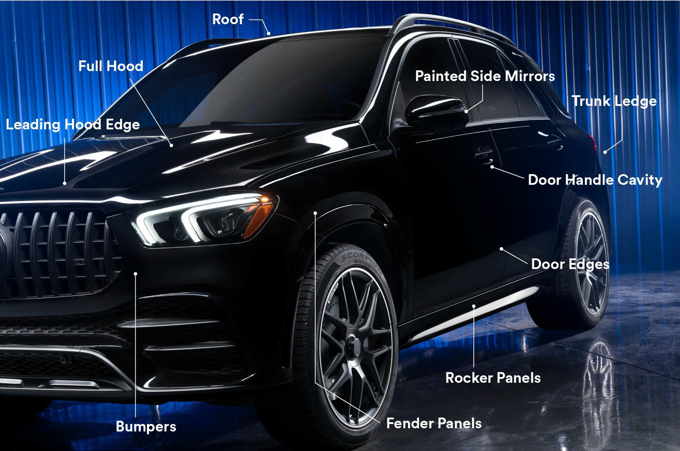Personal and commercial fleet vehicles

Applications shown above indicate typical areas of placement on personal vehicles. Actual film placement will vary according to the needs of the customer.



# Product Line

|  |  |
| --- | --- |
| **Product Name** | **Description** |
| 3M™ Paint Protection Film Series 150 Gloss | Transparent film with a glossy finish |

Cap Sheet — Polyester (not applicable to all areas) Clearcoat — Polyurethane

Film — Polyurethane Adhesive — Acrylic PSA Release Liner — Polyester

# Physical Characteristics

These are the typical values for unprocessed product. Processing may change the values.

## Typical Physical Properties

**NOTE:** The following technical information and data should be considered representative or typical only and should not be used for specification purposes.

|  |  |
| --- | --- |
| **Characteristic** | **Value** |
| **Material** | Polyurethane |
| **Color** | Transparent |
| **Thickness** | **Film with adhesive:** 7.5 mil (0.19 mm)  **Liner:** 2.9 mil (0.08 mm)  **Cap sheet:** 2.0 mil (0.05 mm) |
| **Adhesive** | Acrylic, pressure activated |
| **Adhesive Appearance** | Clear |
| **Adhesion on**  **Automotive Paint (180° peels)\*** | **Initial Adhesion (20 minutes at room temperature):** 3.8 lbs/in. (6.6 N/cm)  **Final Adhesion (24 hours at room temperature):** 4.5 lbs/in. (7.9 N/cm) |
| **Elongation at Break** | 400% |
| **Tensile Strength at Maximum Force** | 2,500 PSI (17.2 MPa) |
| **Liner** | Polyester |

* 3M Commercial Branding and Transportation Division products are not tested against automotive manufacturer specifications.

# Application Characteristics

|  |  |
| --- | --- |
| **Characteristic** | **Value** |
| **Application Method** | Wet only |
| **Substrate Types** | OEM painted surfaces* |
| **Application Temperatures** | 60°F to 85° (16°C to 30°C) |

* See [3M™](https://multimedia.3m.com/mws/media/2356549O/3m-paint-protection-film-installation-guideline.pdf?&fn=3m-paint-protection-film-installation-guideline.pdf) [Paint](https://multimedia.3m.com/mws/media/2356549O/3m-paint-protection-film-installation-guideline.pdf?&fn=3m-paint-protection-film-installation-guideline.pdf) [Protection](https://multimedia.3m.com/mws/media/2356549O/3m-paint-protection-film-installation-guideline.pdf?&fn=3m-paint-protection-film-installation-guideline.pdf) [Film](https://multimedia.3m.com/mws/media/2356549O/3m-paint-protection-film-installation-guideline.pdf?&fn=3m-paint-protection-film-installation-guideline.pdf) [Installation](https://multimedia.3m.com/mws/media/2356549O/3m-paint-protection-film-installation-guideline.pdf?&fn=3m-paint-protection-film-installation-guideline.pdf) [Guidelines](https://multimedia.3m.com/mws/media/2356549O/3m-paint-protection-film-installation-guideline.pdf?&fn=3m-paint-protection-film-installation-guideline.pdf) for complete details.

2 Technical Data Sheet Series 150 Gloss - Revision A, March 2024

# Installation

### IMPORTANT NOTE



i

For optimal application of paint protection film on the vehicle, install at temperatures of 70°F to 79°F (21°C to 26°C).

# Maintenance and Cleaning

* The cleaner must be wet, non-abrasive, without solvents, and have a pH value between 6 and 8 (neither strongly acidic nor strongly alkaline).
* 3M™ Perfect-It™ Show Car Paste Wax (PN39526) can be applied after several days or within a couple months after PPF installation for Series 150. Users must then regularly wash and recoat the surface going forward.
* Alternatively, 3M™ Ceramic Coating or 3M™ Ceramic Boost can applied be for additional hydrophobicity, stain resistance, and easy clean features.
* Do NOT use waxes containing dyes, abrasive polishes, and/or rubbing compounds. The abrasive particles will damage the film surface and result in a loss of surface quality.

# Removal

3M recommends using a heat gun or steamer to aid removal. The correct angle of removal is 30 to 60 degrees from the surface of the paint.

# Shelf Life and Storage

The shelf life is an indicative and maximum data, subject to many external and non-controllable factors. It may NEVER be interpreted as a warranty. The shelf life is 18 months from the date of manufacture on the original box.

### IMPORTANT NOTE



i

3M recommends storage conditions of 60°F to 85°F (16°C to 30°C), out of sunlight, in the original container, and in a clean and dry area.

# Health and Safety

### CAUTION

!

When handling any chemical products, read the manufacturers’ container labels and the Safety Data Sheets (SDS) for important health, safety, and environmental information. To obtain SDS for 3M products go to [3M.com/SDS](http://www.3m.com/SDS). To request SDS by mail, or in case of an urgent situation, call 1-800-364-3577 or 1-651-737-6501.

When using any equipment, always follow the manufacturer’s instructions for safe operation.

Technical Data Sheet Series 150 Gloss - Revision A, March 2024 3

# Warranty Information

## Technical Information

Technical information, guidance, and other statements provided by 3M are based upon records, tests, or experience that 3M believes to be reliable, but the accuracy, completeness, and representative nature of such information is not guaranteed. Such information is intended for people with knowledge and technical skills sufficient to assess and apply their own informed judgment to the information. No license to any intellectual property rights is granted or implied with respect to this technical information.

## Product Selection and Use

Many factors beyond 3M's control and uniquely within user's knowledge and control can affect the use and performance of a 3M product in a particular application. Customer is solely responsible for evaluating the product and determining whether it is appropriate and suitable for customer's application, including conducting a workplace hazard assessment, reviewing all applicable regulations and standards, and reviewing the product label and use instructions. Failure to properly evaluate, select, and use a 3M product in accordance with instructions or to meet all applicable safety regulations may result in injury, sickness, death, and/or harm to property.

## Warranty, Limited Remedy, and Disclaimer

Unless a different warranty is specifically stated on the applicable 3M product packaging or product literature (in which case such warranty governs), 3M warrants that each 3M product meets the applicable 3M product specification at the time 3M ships the product. 3M MAKES NO OTHER WARRANTIES OR CONDITIONS, EXPRESS OR IMPLIED, INCLUDING, BUT NOT LIMITED TO, ANY WARRANTY OR CONDITION OF MERCHANTABILITY, FITNESS FOR A PARTICULAR PURPOSE, OR ARISING OUT OF A COURSE OF DEALING,

CUSTOM, OR USAGE OF TRADE. If a 3M product does not conform to this warranty, the sole and exclusive remedy is, at 3M's option, replacement of the 3M product or refund of the purchase price.

## Limitation of Liability

Except for the limited remedy stated above, and except to the extent prohibited by law, 3M will not be liable for any loss or damage arising from or related to the 3M product, whether direct, indirect, special, incidental, or consequential (including, but not limited to, lost profits or business opportunity), regardless of the legal or equitable theory asserted, including, but not limited to, warranty, contract, negligence, or strict liability.

**Commercial Branding and Transportation**

3M Center, Building 223-3N-30 St. Paul, MN 55144

1-800-328-1684

3M.com/ppf

© 3M 2024. All rights reserved.

3M and Perfect-It are trademarks of 3M. Used under license in Canada.

All other trademarks are property of their respective owners. Revision A, March 2024 Please recycle.