Traffic Safety and Security Division
3M™ Manual Tape Applicator MTA-2
3M™ Stamark™ Pavement Marking Tapes
February 2018

Description

The 3M™ Manual Tape Applicator MTA-2 is in intended to be used for the application of 3M™ Stamark™ pavement marking tapes. It is a simple-to-use, two-wheeled, robust, push-type device. (Figure 1)
The usage of A380ESD (high tack adhesive) demands installation of the MTA-2 upgrade-kit DR995032239 to prevent roll blocking by the high tack adhesive during the tape application.
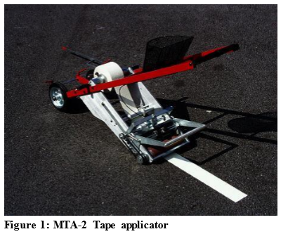

The device is specifically designed to apply pavement marking tapes precoated with pressure sensitive adhesive. The applicator weighs 75kg and can be partially disassembled for transporting in a van, truck or station wagon.

Product Width and Spacing

The MTA-2 can be used to apply all 3M™ Stamark™ pavement marking tapes at all standard roll length. Note: If special roll with larger length are being ordered, the maximum roll diameter must not exceed 50cm, if the material is to be applied with a Manual Tape Applicator.

Operation

The MTA-2 is operated by one person.
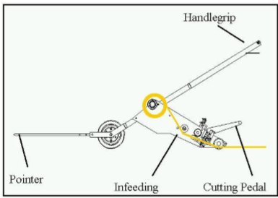
Note: Pavement Marking Roll changing should be supported by a second person due to the weight of a tape roll in order to avoid extensive workload for a single operator. The application rates depend on the individual application conditions and environment. Typically, tape is being applied at walking speed.

Procedure for Adjusting Machine and Tape

Load the tape roll, feed it in to the machine and do the necessary adjustments, as shown in Figure 3 to 8. As soon as these steps are done, the machine is ready for the application.
Caution: Do not activate the cutting knife, while doing adjustments!
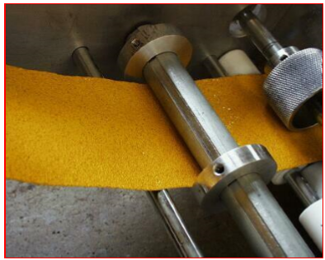

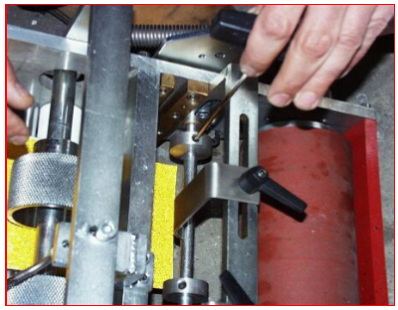
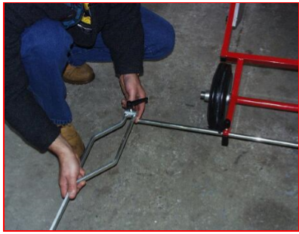
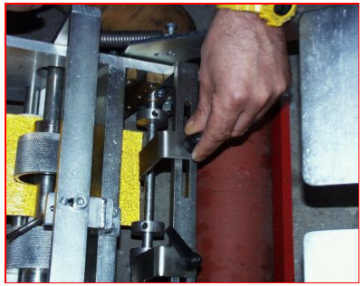
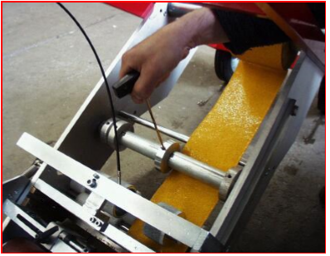

Tape Application

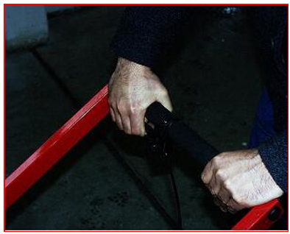
Determine where the first skip or long line starts by measuring from the last existing skip or reference mark. Adjust the pointer to the pre-marking. Best case is when the pre-marking and the later tape position are in between the wheels of the applicator. If primer is used apply tape exact on primer. For starting the application pull handgrip and watch tape being moved by infeeding-transportation roll. Position tape start at start of pre-marking. Push applicator forward and keep handle grip pulled until tape appears on other side of rubber application roll. Release handle-grip and keep pushing applicator.
For applying Stamark A380 ESD, plasma anti-adhesive rolls have to be added to the MTA-2.

Tape Cutting

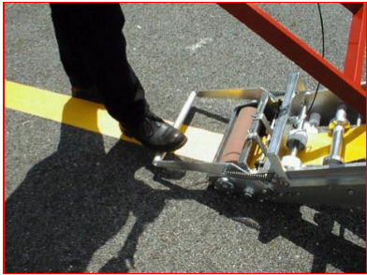
Bring the applicator to a complete stop. Keep tape under slight tension. Cut tape with one strong and fast movement of foot pedal. Release the pedal slowly. Do not attempt to cut the tape while moving. Cutting the tape in motion will stretch and tear the tape, causing the next line to start off center.

Tamping

After applying the Pavement Marking Tape tamp with the tape thoroughly with the RTC-3 with a minimum 90kg (200lb.) load.
When using the RTC-3 Roller Tamper Cart:
- Do not twist or turn the tamping device on the tape.
- Make three passes back and forth over each part of the tape
- Move the RTC-3 slowly (4-5 km/h) over the tape • Make sure all edges are firmly adhered
- If applying block markings or pedestrian crossings, start in the center of the marking, then work towards the edges to remove trapped air.
- Open road to traffic as soon as tamping is completed
Tamping is most important !

Maintenance

Keep all Fasteners Tight
Lubrication: The pivot points and sliding areas should be kept lubricated with light oil.
Cleaning: The silicone application roller wheels and cutting mechanism must be kept clean. Mineral spirits, fuel oil or any other light oil cleaners may be used on the wheels and knives. Check knife blades from time to time to prevent adhesive build-up. Solvents may be used occasionally for difficult cleaning problems. A spray bottle of cleaner or silicone spray is useful to prevent asphalt and dirt pickup on the wheels and adhesive buildup on the knives during operation.
Caution: Do not use solvents or petroleum products on the silicone application roll when working on new, hot asphalt surfaces. To prevent asphalt buildup around the roller untighten the scraper mounting screws and move the scraper back. Tighten the screws.

Adjustments

The Knifes are pre-adjusted by the manufacturer to slide across each other with a minimum of friction in a scissors action. Adjustment is needed when the tape is not properly cut. Either the stationary knife or the slilding knife may be adjusted. To adjust the stationary knife, untighten the mounting screws slightly. Turn the setscrews to bring the cutting edge down, and retighten the mounting screws. The same procedure is followed to adjust the sliding knife. Each knife has two cutting edges. The knives may be removed and new cutting edges exposed. The knives may be sharpened after the cutting edges are dull.

Trouble Shooting

Tape is not properly cut: The tape will not cut cleanly if cutting is done while the applicator is in motion. If the knife edges are dull or out of alignment, the knives should be sharpened and adjusted. (See Adjustments). Clean adhesives build up from knives. (See Maintenance).

MTA-2 – Spare Parts:

Description 3M Order Number
Anti-adhesive rolls DR-9950-3223-9 (Order via 3M Customer Service)
Other spare parts are available from the company Kötter und Sperber Industrietechnik GmbH Phone: +49 2129 3796843 www.ksimetall.de

12.1 Health and Safety Information

Precautions:
Wear safety shoes and appropriate gloves while handling and using the Manual Tape.

Read all health hazard, precautionary and first aid statements found in the Material Safety Data Sheet (MSDS), and/or product label of chemicals prior to handling or use.

12.2 Disclaimer

The 3M warranty is made in lieu of all OTHER warranties OR CONDITIONS, express or implied, including but not limited to any implied warranty or condition of merchantability, or fitness for a particular purpose, or any implied warranty arising out of a course of dealing or of performance, custom or usage of trade.

12.3 Limitation of Liability

Except for the limited remedy stated above, and except where prohibited by law, 3M will not be liable for any loss or damage arising from the Signs or any 3M product, whether direct, indirect, special, incidental or consequential damages (including but not limited to lost profits, business or revenue in any way), regardless of the legal theory asserted including warranty, contract, negligence or strict liability.

13 Other Product Information

Always confirm that you have the most current version of the applicable product bulletin, information folder or other product information from 3M’s Website at http://www.mmm.com/tss.

14 Guarantee /Liability

3M assumes no responsibility for any injury, loss or damage arising out of the use of a product that is not of our manufacture. Where reference is made in literature to a commercially available product, made by another manufacturer, it shall be the user's responsibility to ascertain the precautionary measures for its use outlined by the manufacturer. Prerequisite for the guarantee is that the tape was processed according the instruction of this technical information folder.

15 Literature References

For additional information on 3M™ Stamark™ Tapes, Application Instructions or 3M™ Application Equipment, refer to the following publications:
IF P50 Information Folder Surface Preparation Adhesive 3M™ Stamark™ P50
IF PS-98 Information Folder Adhesive Spray Applicator PS-98
IF OV Information Folder Overlay Application
IF AP Information Folder Inlay Application
IF BPlus Information Folder BitumenPlus Application
IF MTA2 Information Folder Manual Tape Applicator MTA-2
IF RTC-3 Information Folder Roller Tamper Cart RTC-3

PB A340 Product Bulletin 3M Stamark™ Durable Tape A340
PB A380 Product Bulletin 3M Stamark™ High Performance Tape A380
PB A650 Product Bulletin 3M™ Stamark™ Temporary Tape Series A650
PB A540 Product Bulletin 3M™ Stamark™ Temporary Tape Series A540
PB A720 Product Bulletin 3M™ Stamark™ Temporary Wet Reflective Tape Series A720

Important Notice to Purchaser | All statements, technical information and recommendations herein are based on tests we believe to be reliable, but the accuracy or completeness thereof is not guaranteed. Before using, user shall determine the suitability of the product for its intended use, and user assumes all risk and liability whatsoever in connection therewith. All questions of warranty and liability relating to this product are governed by the terms of the sale subject where applicable to the prevailing law. No statement or recommendation not contained herein shall have any force or effect unless in an agreement signed by officers of seller and manufacturer.

 |  |  | 3M, Controltac und Comply sind eingetragene Marken der 3M Company. Alle anderen Markenzeichen gehören ihrem jeweiligen Eigentümer.  Der Einsatz von Markenzeichen und Markennamen in diesen Produktinformationen richtet sich nach den in den USA geltenden Vorgaben. Diese können sich von denen in anderen Ländern unterscheiden.
  Reliant for these product-information:
  3M Deutschland GmbH
  Safety & Graphics Laboratory
  Carl-Schurz-Str. 1
  41453 Neuss, Deutschland
  3M Deutschland GmbH  Verkehrssicherheit  Carl-Schurz-Straße 1  41453 Neuss  Tel: 02131/14 7475  Fax: 02131/14 3200  E-Mail: Verkehrssicherheit@mmm.com  www.3M.de/verkehrssicherheit  Änderungen vorbehalten  Technische Information IF AP/ 02.2018  © 3M 2018. All rights reserved. |  | 3M Österreich GmbH  Verkehrssicherheit  Euro Plaza, Gebäude J  Kranichberggasse 4  1120 Wien  Tel: +43(0)1/86686-0  Fax: +43(0)1/86686-242  E-Mail : verkehrssicherheit-at@mmm.com  www.3m.com/at |  | 3M (Schweiz) GmbH  Verkehrssicherheit  Eggstrasse 93  8803 Rüschlikon  Tel : +41447249272  Fax : +41447249450  E-Mail: verkehrssicherheit-ch@mmm.com  www.3m.com/ch/verkehrssicherheit

